AIM : Stack implementation

[B] : : Implement a Stack using linked list and perform the stack operations: Push, Pop and Print using Menu Driver Program such as 1.Push, 2.Pop and 3. Print and 4. Exit.

PROGRAM :

#include <stdio.h>

#include <stdlib.h>

struct Node {

int data; struct Node* next;

};

struct Node* top = NULL;

void menu() { printf("1.PUSH\n2.POP\n3.PRINT\n4.EXIT\n");

}

void PUSH() { struct Node* newNode = (struct Node*)malloc(sizeof(struct Node)); if (!newNode) { printf("Stack Overflow\n"); return;

}

printf("Enter value to push: "); scanf("%d", &newNode->data); newNode->next = top; top = newNode;

}

void POP() { if (top == NULL) { printf("Stack Underflow\n"); return;

}

struct Node* temp = top; printf("Pop element: %d\n", top->data); top = top->next; free(temp);

}

void PRINT() { if (top == NULL) { printf("No Element in Stack\n"); return;

}

struct Node* temp = top; printf("Elements in stack are:\n"); while (temp != NULL) { printf("%d \n", temp->data); temp = temp->next;

}

}

int main() { char ch; do { menu(); int choice; printf("Enter choice: "); scanf("%d", &choice); switch (choice) { case 1: PUSH(); break; case 2: POP(); break; case 3: PRINT(); break; case 4: return 0;

default:

printf("Invalid Choice\n"); break;

}

printf("\nDo you want to continue(Y/N): "); scanf(" %c", &ch);

} while (ch == 'y' || ch == 'Y'); return 0;

}

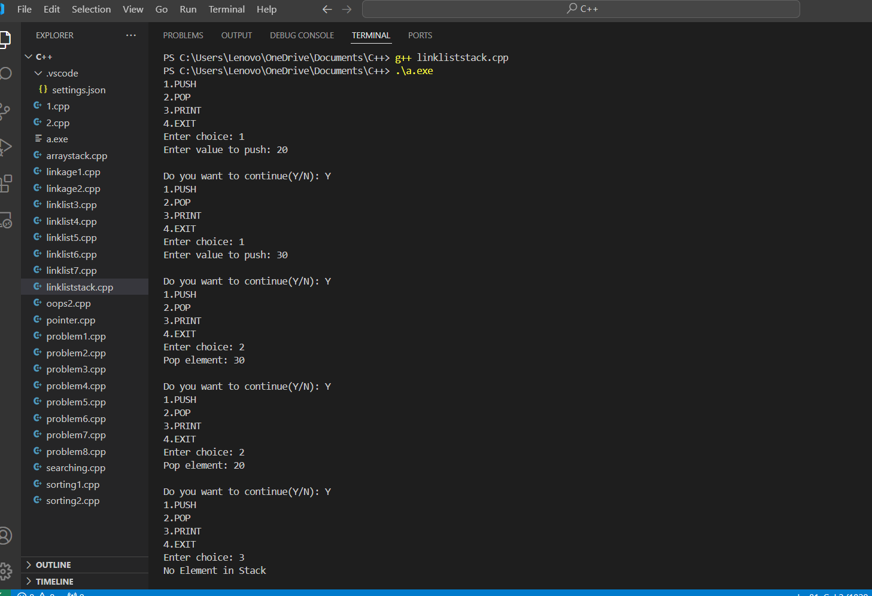

GITHUB LINK : <https://github.com/Manas1597/DSA>

# PRACTICAL NO : 5